Experiment 2 : Develop a program to deploy intrusion detection system using ultrasonic and sound sensors
Date : 19.08.2025
Aim:
To develop the intrusion detection system using ultrasonic and sound sensors

Components Required:
S.No | Components Name | Range/Rating | Quantity
1 | Universal Bread Board |  | 1
2 | Arduino Uno board |  | 1
3 | HC-SR04 Ultrasonic Sensor |  | 1
4 | Sound Sensor (Microphone Module) |  | 1
5 | Buzzer or LED
6 | 12V Adaptor |  | 1
7 | Power jack |  | 1
8 | USB Cable |  | 1
9 | Jumper Wires |  | required

HC-SR04 Ultrasonic Sensor: Emits ultrasonic waves and measures the time taken for the echo to return, allowing distance calculation to detect objects or intruders within a defined range.
Sound Sensor (Microphone Module): Detects sound levels and can be used to identify unusual noises associated with an intrusion.
Buzzer or LED: Provides an audible or visual alarm when an intrusion is detected.

Hardware Procedure:
- Strategically place the ultrasonic sensor to cover the desired detection area and the sound sensor to monitor for unusual noises.
- Power the Arduino using a USB cable or an external power supply
Hardware Setup:
Setting up the hardware
- Ultrasonic sensor connection:
  - Connect the VCC pin to a 5V pin on the Raspberry Pi.
  - Connect the GND pin to a ground pin on the Raspberry Pi.
  - Connect the TRIG pin to a GPIO pin on the Raspberry Pi (e.g., GPIO 20).
  - Connect the ECHO pin to another GPIO pin on the Raspberry Pi (e.g., GPIO 26) through a voltage divider (using resistors to lower the 5V output of the sensor to the 3.3V acceptable by the Raspberry Pi's GPIO pins).
- Sound sensor connection:
  - Connect the power and ground pins to the Raspberry Pi's corresponding pins.
  - Connect the data/output pin to an available GPIO pin on the Raspberry Pi (e.g., GPIO 17).
- Output devices (buzzer/LEDs):
  - Connect the buzzer's positive terminal to a GPIO pin and the negative terminal to ground.
  - Connect the anode (longer leg) of an LED to a GPIO pin through a current-limiting resistor, and the cathode (shorter leg) to a ground pin

Connection Diagram:-

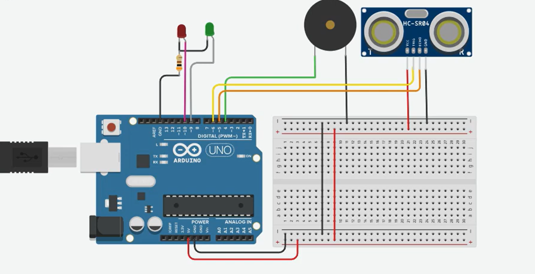

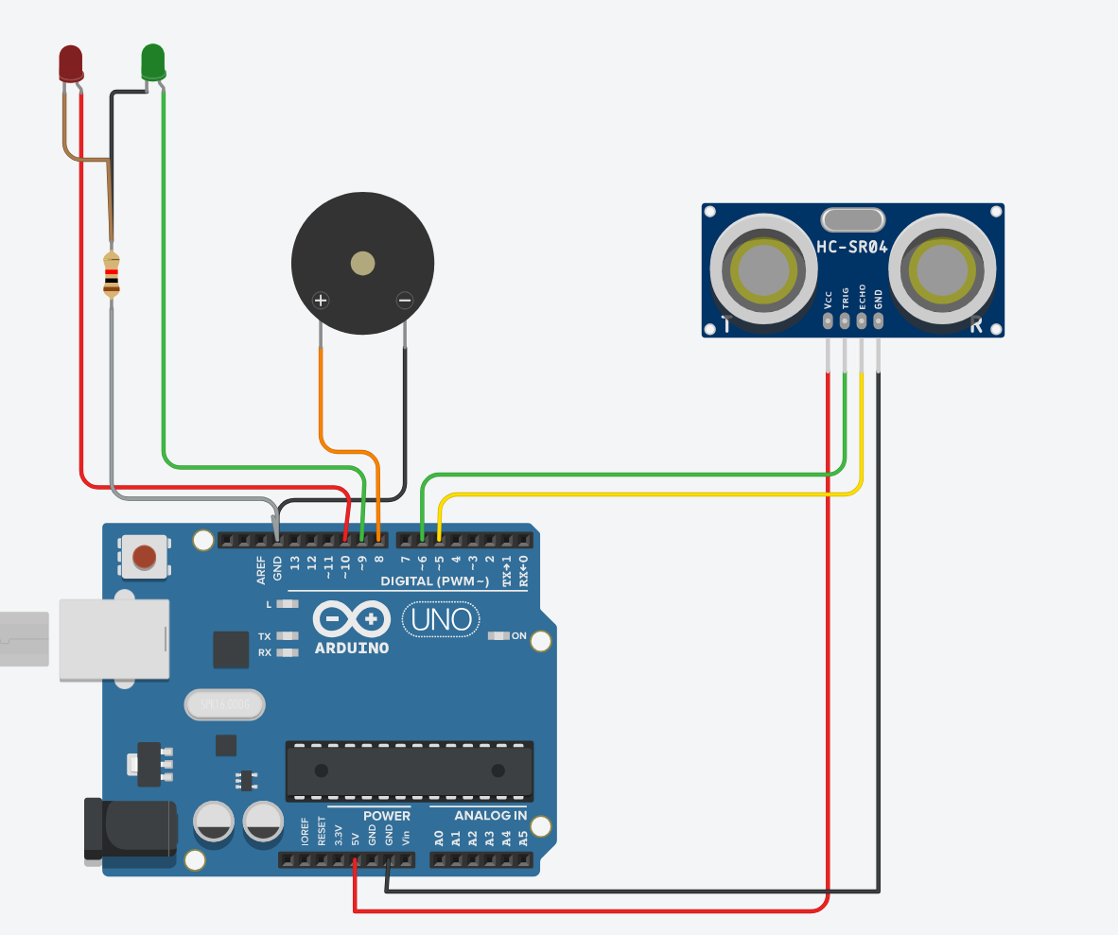
Program
// C++ code
//
int input = 0;

long readUltrasonicDistance(int triggerPin, int echoPin)
{
pinMode(triggerPin, OUTPUT); // Clear the trigger
digitalWrite(triggerPin, LOW);
delayMicroseconds(2);
// Sets the trigger pin to HIGH state for 10 microseconds
digitalWrite(triggerPin, HIGH);
delayMicroseconds(10);
digitalWrite(triggerPin, LOW);
pinMode(echoPin, INPUT);
// Reads the echo pin, and returns the sound wave travel time in microseconds
return pulseIn(echoPin, HIGH);
}

void setup()
{
Serial.begin(9600);
pinMode(8, OUTPUT);
pinMode(9, OUTPUT);
pinMode(10, OUTPUT);
}

void loop()
{
input = 0.01723 * readUltrasonicDistance(6, 5);
Serial.println(input);

if (input < 100) {
digitalWrite(8, HIGH);
digitalWrite(9, HIGH);
digitalWrite(10, LOW);
} else {
digitalWrite(8, LOW);
digitalWrite(9, LOW);
digitalWrite(10, HIGH);

}
delay(10); // Delay a little bit to improve simulation performance
}
Working Observation:
- Create a loop to read both sensor values continuously. Define a distance threshold for the ultrasonic sensor. Use conditional logic to trigger an alarm if an object is within the threshold and sound is detected.
- Test the system by simulating an intrusion and adjust the ultrasonicThreshold and soundThreshold values in the code as needed to optimize detection sensitivity and minimize false alarms.
- Activate a buzzer or LEDs upon intrusion detection.

RESULT: intrusion detection system is successfully implemented with Arduino microcontroller Board.

